Hackathon

Course – CS310

Name - Prateek Agrawal  
Roll No - 20BCS101  
Date - 4th February, 2022

**1)Conceptual Data Model (Crow Foot Notation):**

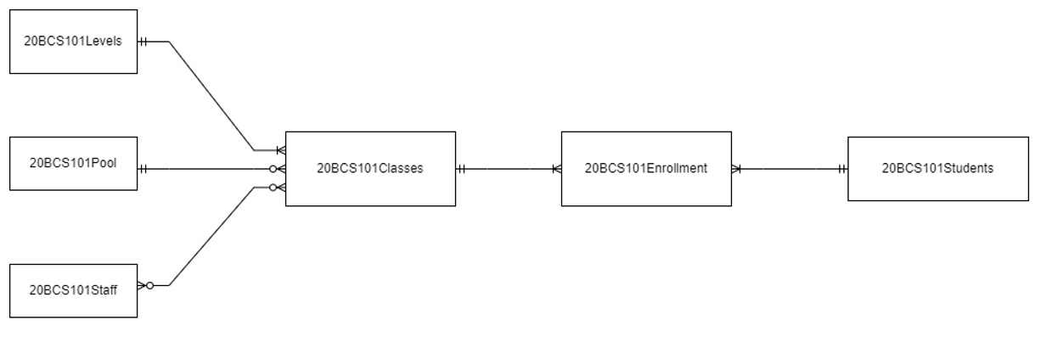

**Peter-Chenn Notation**

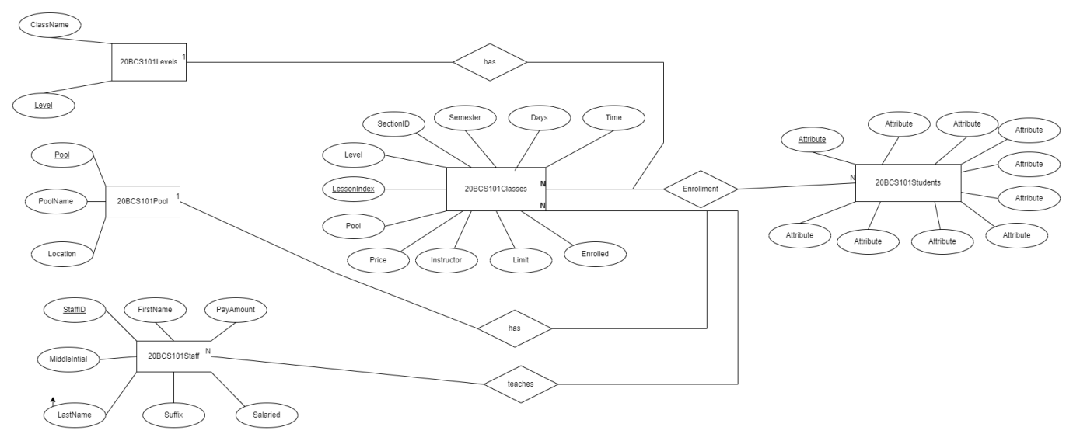

**Schema:**

20BCS101Levels(Level, ClassName)

20BCS101Pool(Pool, PoolName, Location)

20BCS101Staff(Staff, FirstName, MiddleName, LastName, Suffix, Salaried, Payamount)

20BCS101Classes(Lessonindex, Level, Pool, Instructor, SectionID, Days, Time, Limit, Enrolled, Price)

20BCS101Enrollment(Lessonindex, SID, Status, Charged, AmountPaid, DateEnrolled)

20BCS101Students(SID, FirstName, MiddleIntial, LastName, Suffix, Birthday, LocalStreet, LocalCity, LocalPostalCode, LocalPhone)

**2)Degree and Cardinality:**

|  |  |  |
| --- | --- | --- |
| 20BCS101Staff | Optional 1-Optional Many | 20BCS101Classes |
| 20BCS101Pool | Mandatory 1-Optional Many | 20BCS101Classes |
| 20BCS101Levels | Mandatory 1-Mandatory Many | 20BCS101Classes |
| 20BCS101Classes | Mandatory 1-Mandatory Many | 20BCS101Enrollment |
| 20BCS101Enrollment | Mandatory Many- Mandatory 1 | 20BCS101Students |

**3) Physical Data Model:**



**4)** 20BCS101Enrollment is a weak entity.

The table 20BCS101Enrollment relates 20BCS101Classes and 20BCS101Students and it does not have primary key so it is an associative entity which is actually a weak entity. We cannot make it a strong entity by adding a primary key as it will defeat the purpose of it acting as an m:n relation(associative entity) between class table and student table.

**5)** There is no Data redundancy in the schema. We can say this because there no same data attributes which are present in two separate tables.